Performing a Document Comparison in NetDocuments.

To compare documents in Word using ndOffice application:
- In Word, select the Reviewretab, and then select Compare in the ndCompare group.
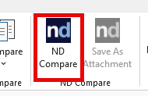
- In the Compare Documents dialog box, select the original and revised documents to compare by selecting one of the following icons:
- - Select the document from the NetDocuments repository. After selecting this icon, the ndOpen dialog box opens, where you can navigate to the specific location, and then select the document.
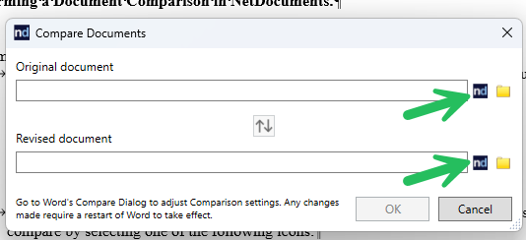

- After comparing the selected documents, you can:
- Open the ndSave dialog box. The Compared Documents folder appears where two documents are located: the original document and the revised one. The original document is preselected and the Save as new version check box is selected by default. Select Save.
- Select Save As Attachment, in the ndCompare group of the Review tab, to save the compared document as an attachment to the original document. ndCompare saves the document to the Comparisons subfolder of the Echo folder. For more information, see Echo Folder.
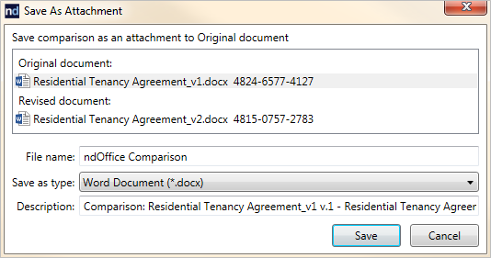

4911-9550-2771, v. 1

